Day 8

Class Exercise 3

@PostMapping("/student")

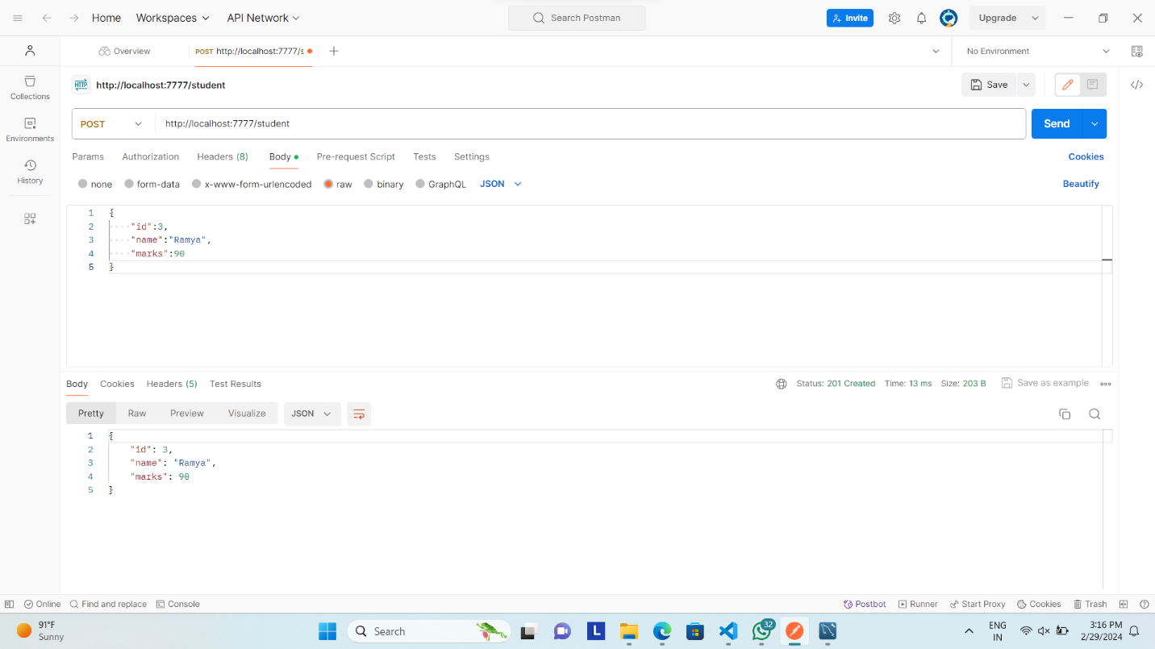

@GetMapping("/student/marksGreaterThan/{mark}")

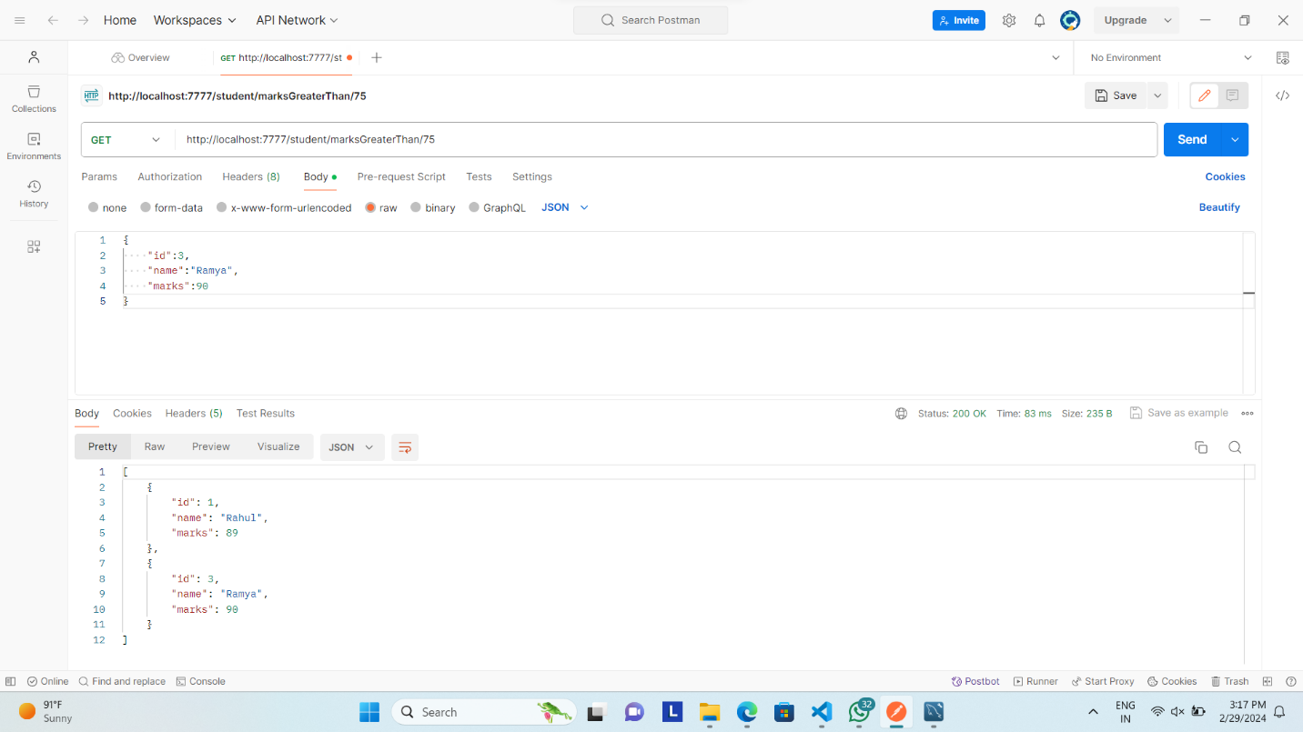

@GetMapping("/student/marksLessThan/{mark}")

